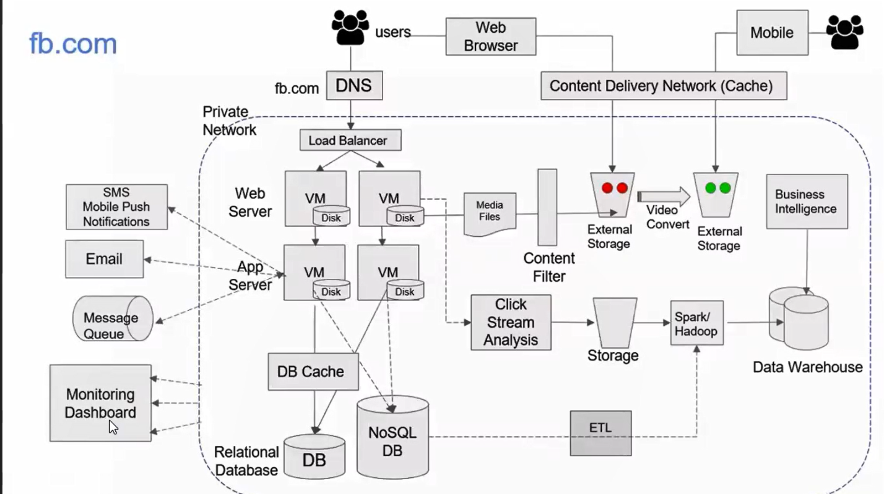

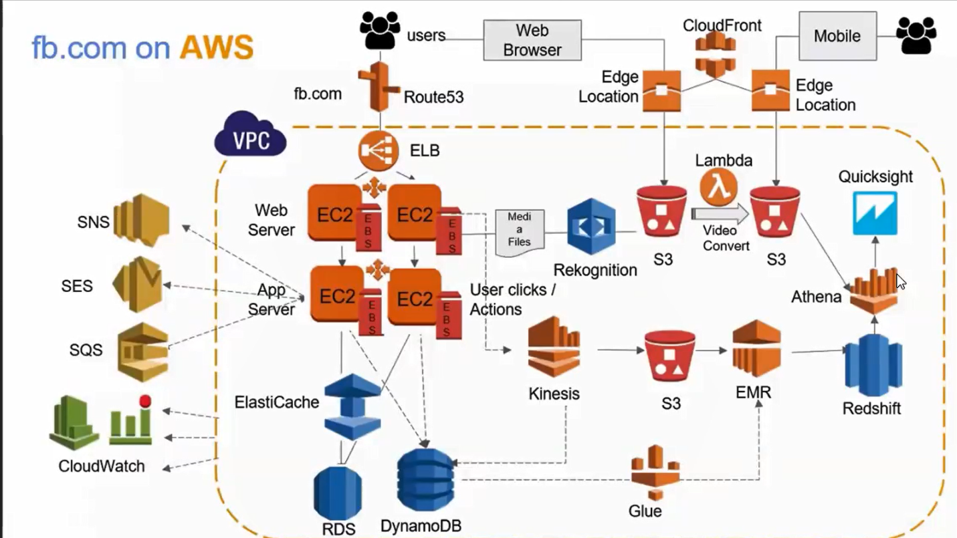

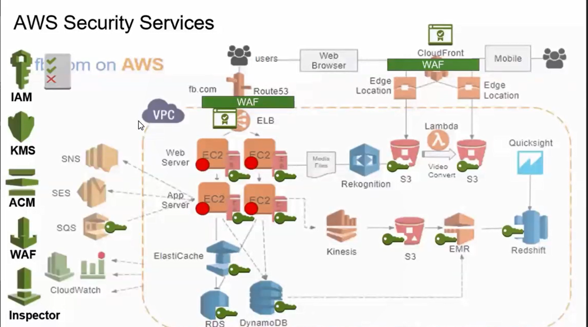

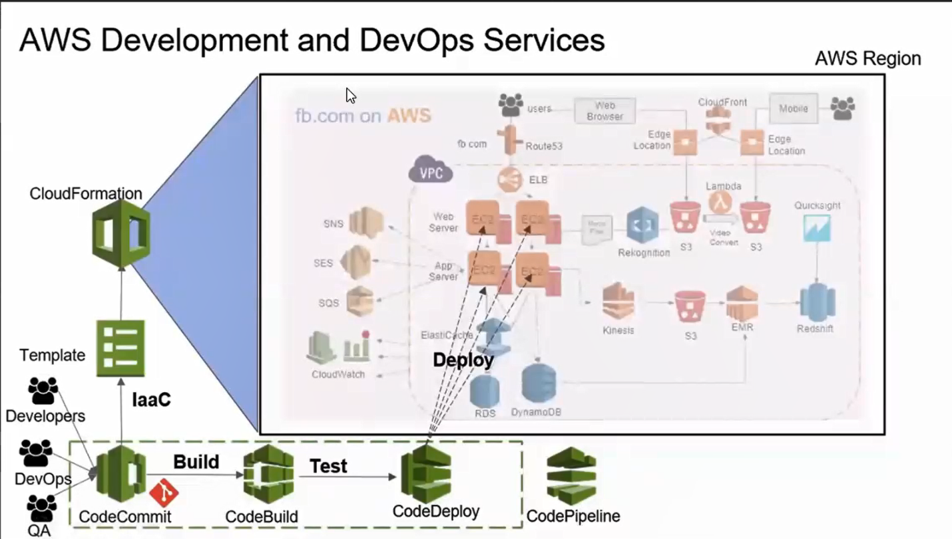

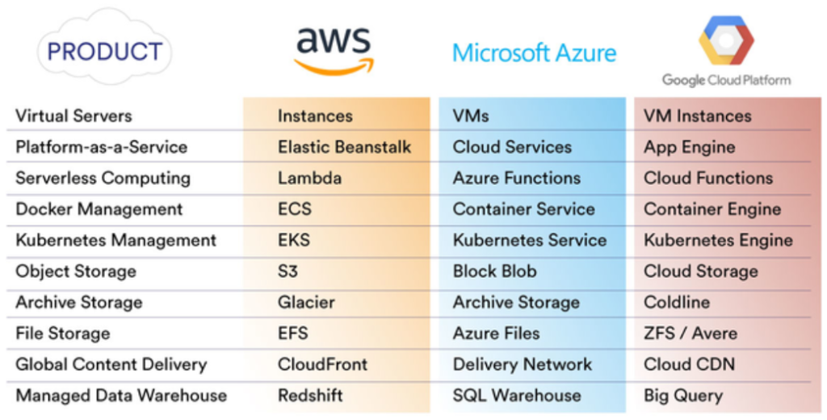

Aws regional service :

قبل ما نحط أي مشروع على منطقه معينه لازم نتاكد ان الخدمات الى احنا محتاجينها موجوده عليها و الا هنضطر نعيد كل الشغل على منطقه تانيه ف اى وقت

Resources :

Create أي حاجه ينفع نعملها

Group ,user, role, policy, vm ,hard disk ,storage bucket,….

Group: logical container أي يوزر بيتحط ف الجروب و بعدل الصلاحيات للناس الى جواها مره واحده

ARN: AMAZON Resource number

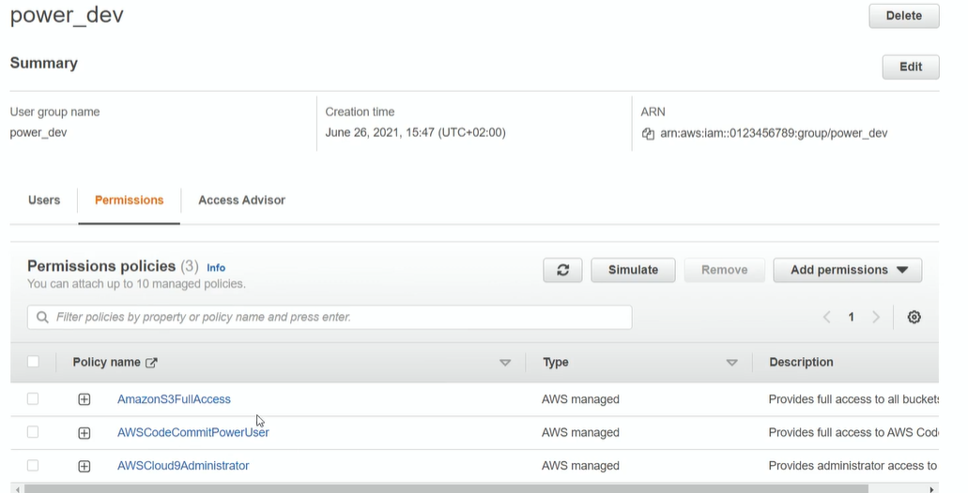

User : MFA (multy factor authentication)

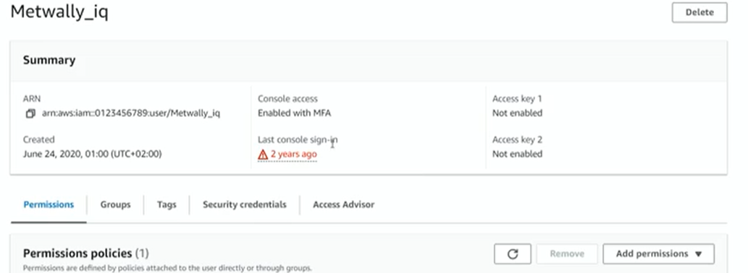

Users can be secured used different ways :

* Permissions (directly or inherited from group permissions).
* Security credentials (password).
* MFA :enable and use Authy .
* Access keys : we can use in code when use scripts like cli or aws sdk or any http req.
* SSH public key : for aws code commit .
* https git credentials :for aws code commit.
* Credentials : for aws key spaces
* Ssl certificate

Roles:

Identity take privilege and ll be assigned to any amazon resource(vm,ec2,…)

Select who is the trusted resources to use another specific resource

Polices :

Group of permissions أي برميشن لازم يكون جوه بوليسي حتى لو واحده لوحدها لازم يتحط جوه بوليسي

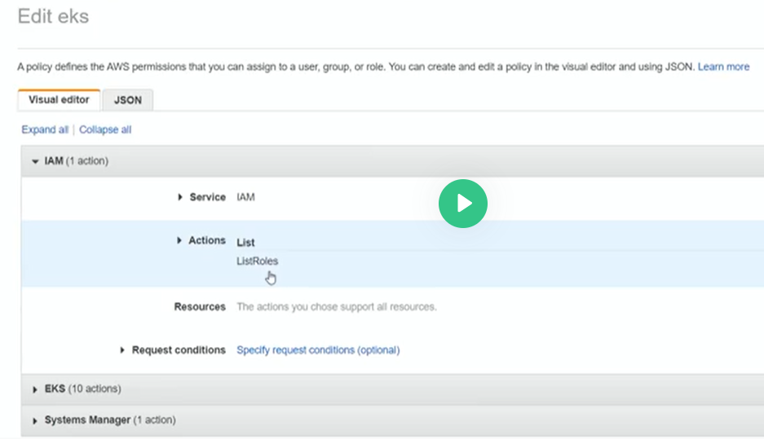

Setup cli:

-settings 🡪 for developers 🡪 enable install apps from any source

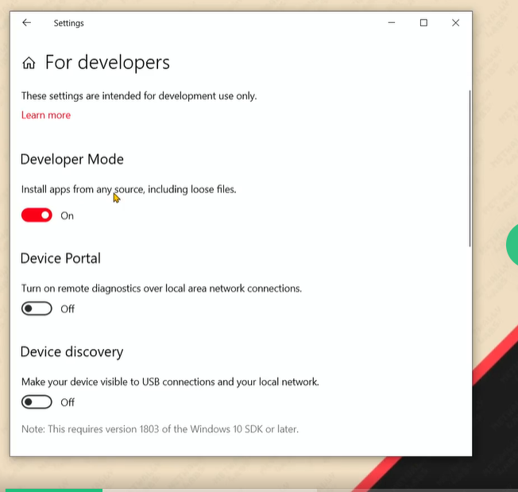

-windows features on,off 🡪 enable windows subsystem for linux 🡪restart

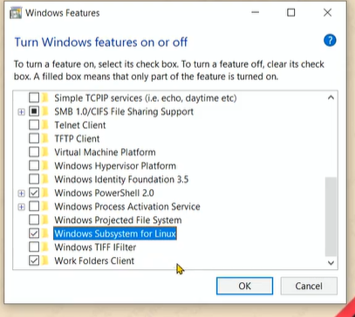

Microsoft store and search for ubuntu 🡪enter username and password.

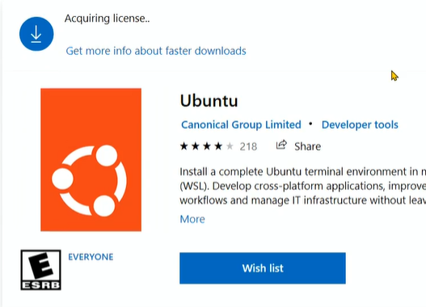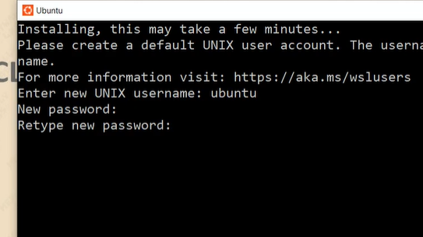

All ubuntu files ll be located in mnt/c

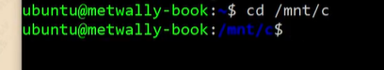

Ll:

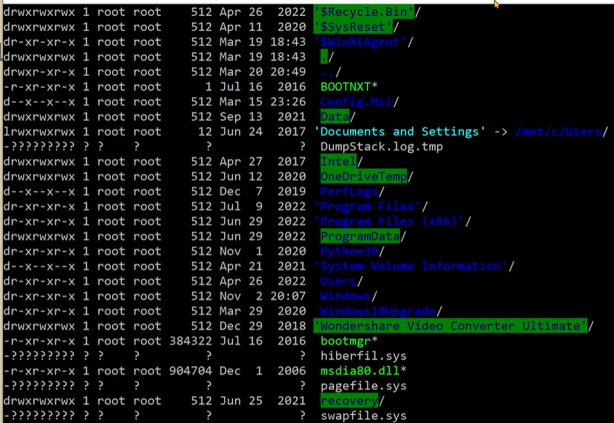

Install AWS cli :

Aws documentation 🡪 user guide🡪about aws cli 🡪 getting started 🡪prerequistites

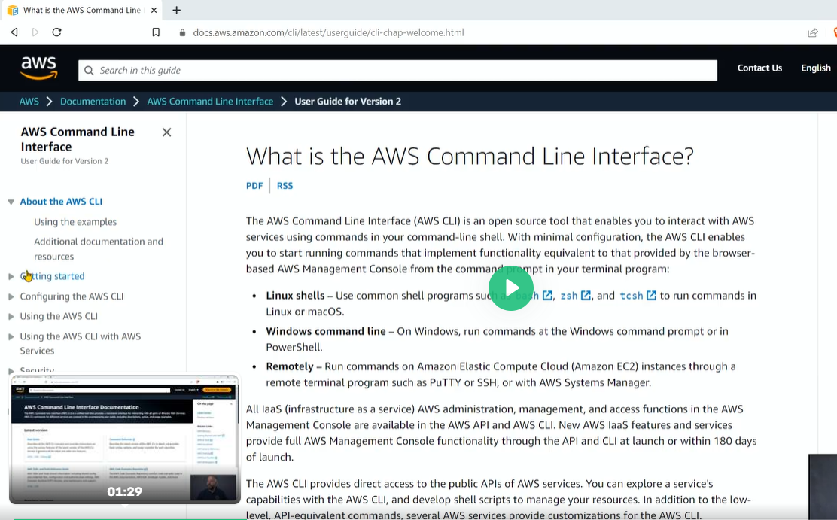

* Create group and assign permissions to this group 🡪

let this group access IAM , ec2, s3,rout33, called devops

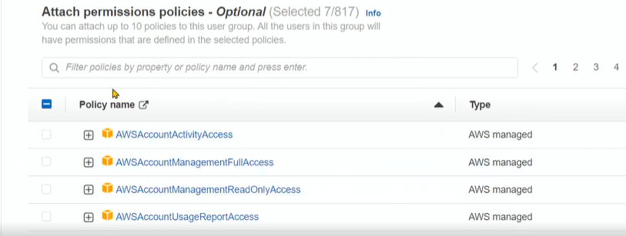

* Create user 🡪 provide user access 🡪 and add password for this user 🡪 add this user to group devops 🡪create access key to avail cli scripts to this user

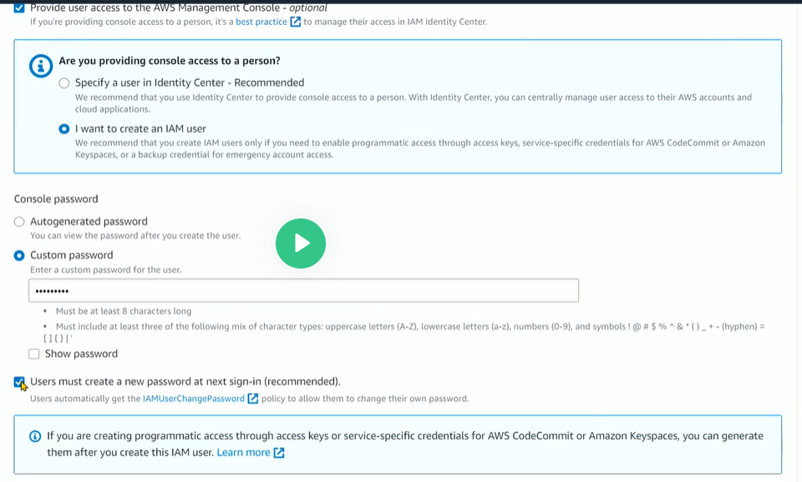

* Download .csv

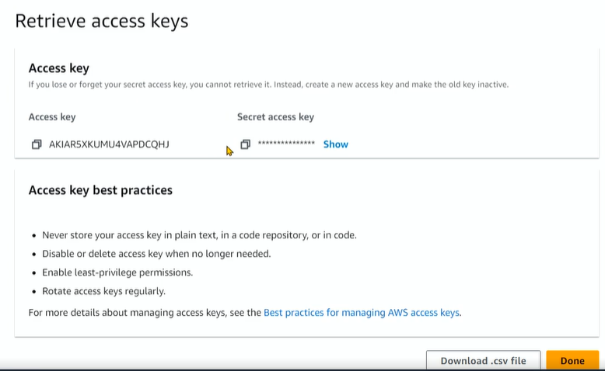

* Download aws cli

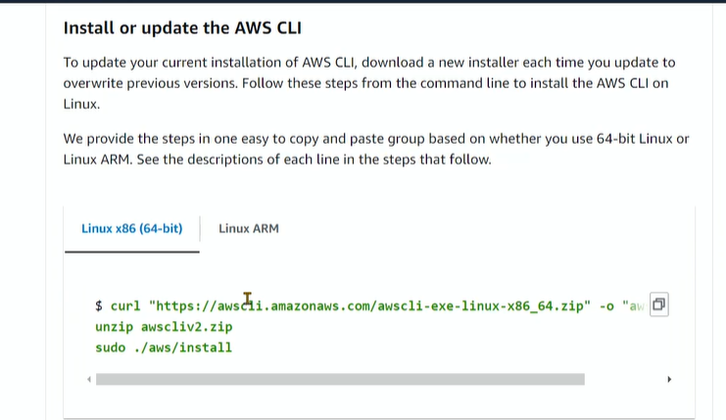

To check if installation done



Configure aws cli 🡪

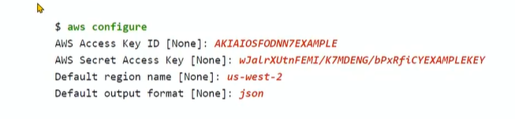

-Access key from the file we downloaded

- 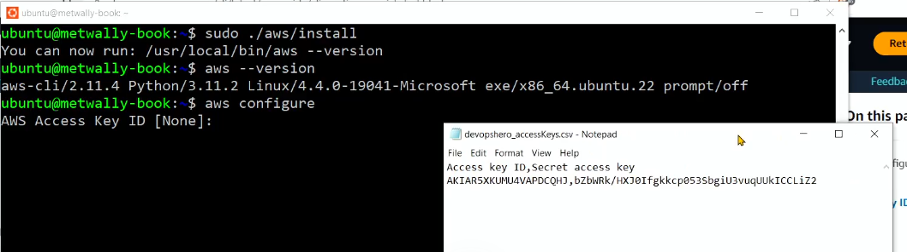

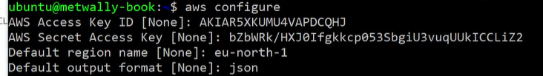

Try cli :

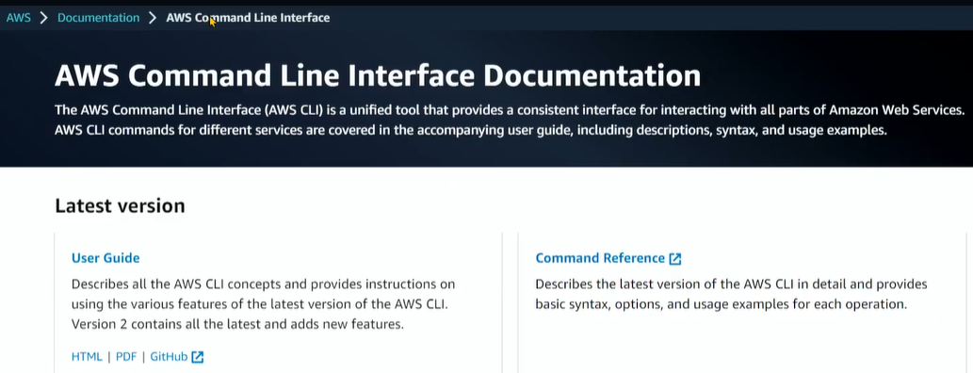

* Command reference 🡪 select IAM 🡪 I want to list groups 🡪
* 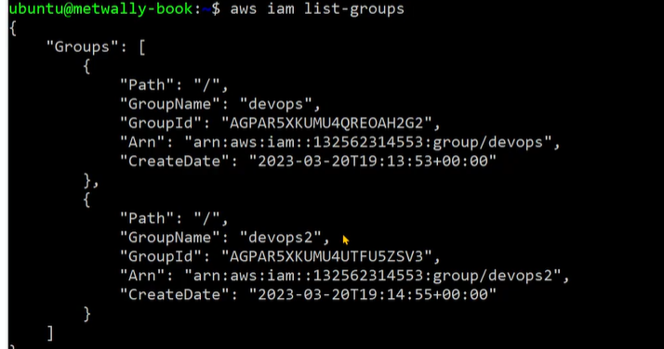

# S3 – Intro – Create Bucket , Object and Permissions from Console

Bucket :مساحه تخزينيه غير محدده

bucketمفيش أي حاجه تربد الملفات ببعض غير انهم يكونو جوه نفس ال

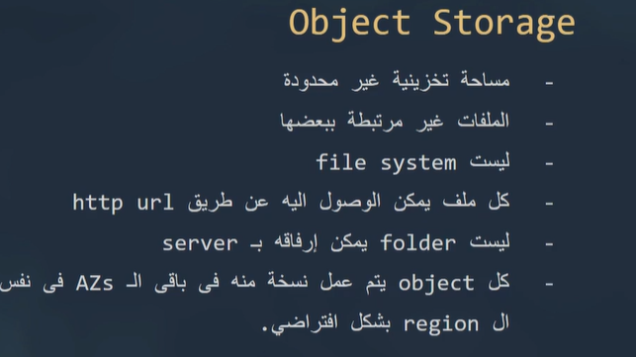

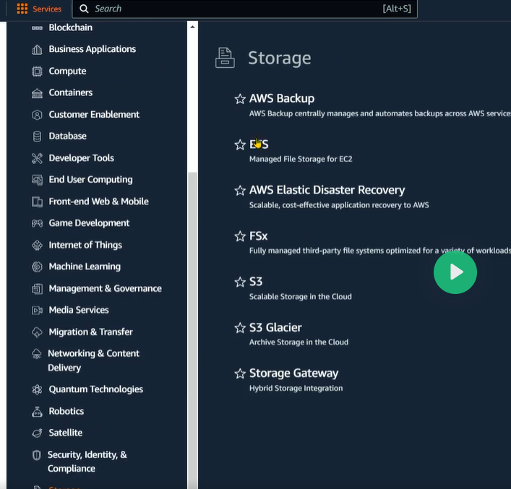

* Create bucket 🡪 Active control list ACL(نسمح او نمنع لبعض الناس تدخل للباكت ده تكنب و تقرا )

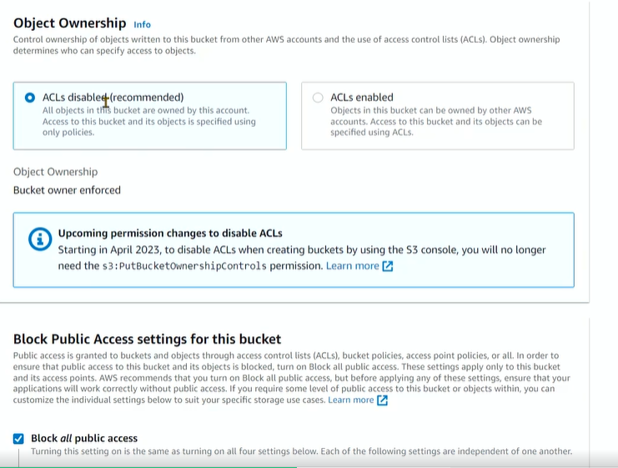

* Add files to my bucket

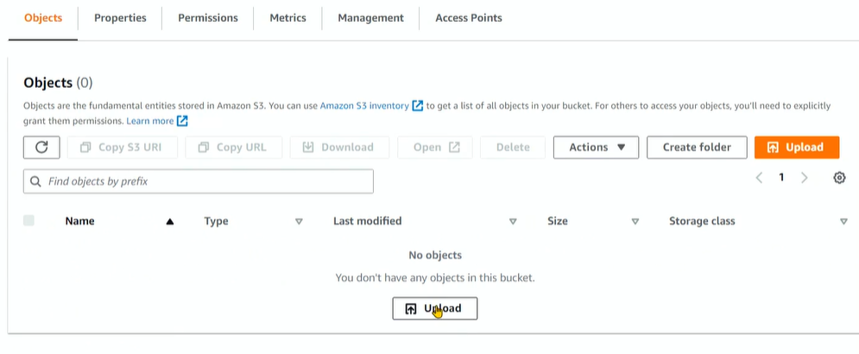

-Public means 0.0.0.0 , in principles = *

-Default access is denied till another policy accessed with different principle

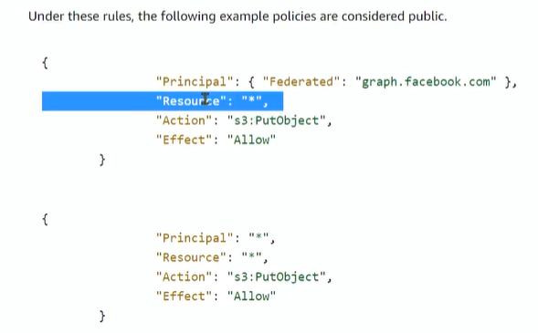

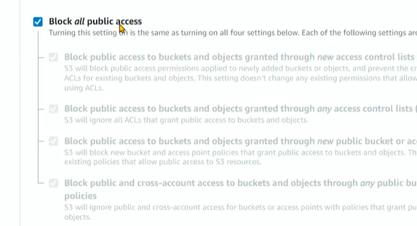

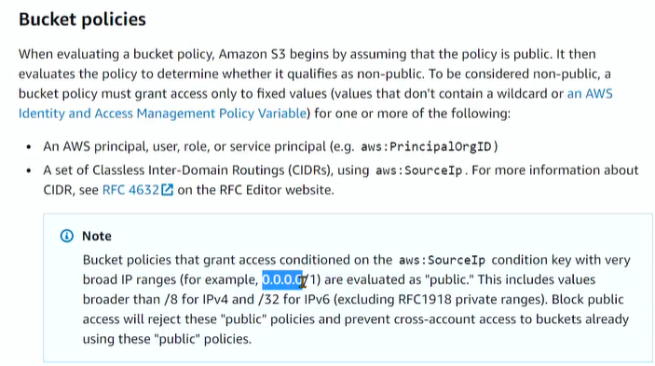

مش بيتعدل هو بيتبدل يعني بيتمسح و يتحط بداله الجديد S3 على Object ال

: Tag ده زي تعليق بيتكتب على ال resource بيبقى key,value

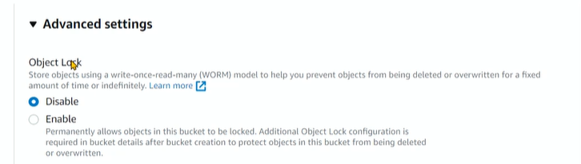

ده معناها ان مفيش حد يقدر يمسح الفايل ده و لا يغيره و بالتبعيه ال bucket versioning هيبقي enabled

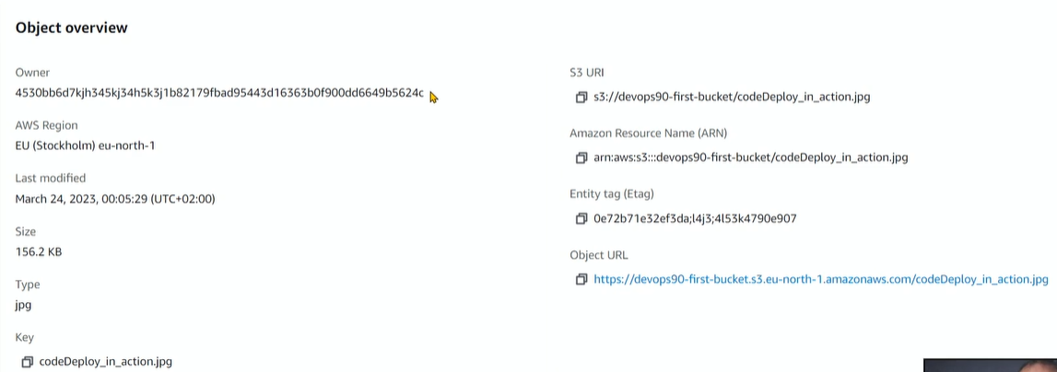

**OWNER :canonical id biggest id for the user account**

**S2 uri: id used in policies :**

**NRI: id of the object don’t repeated in aws averall**

**S3 URL : to access the object over internet**

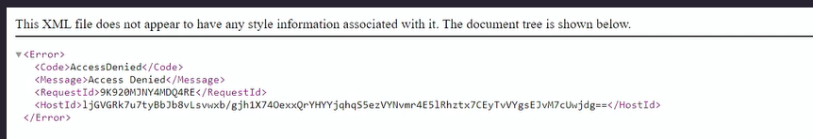

**Access denied because I don’t have permission I closed all public access and**

**I should avail it to enable http req access**

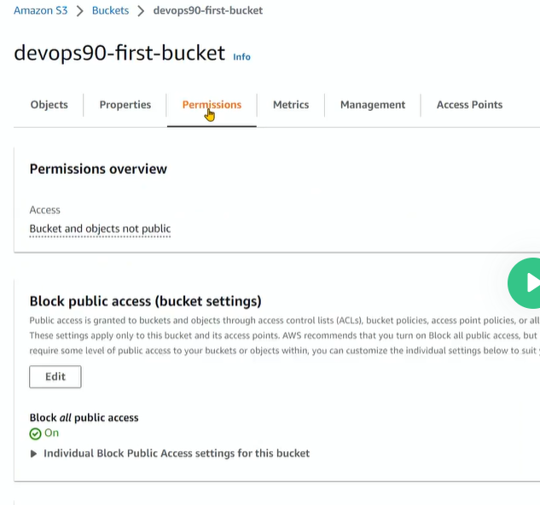

**And enable oenwership**

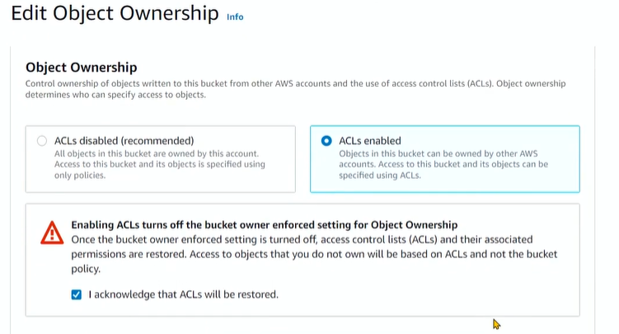

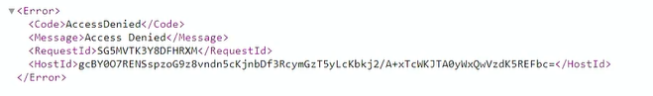

**Still access denied :**

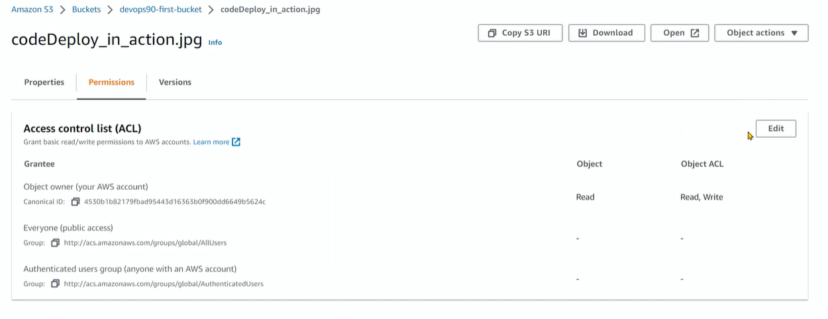**edit ACL and read**

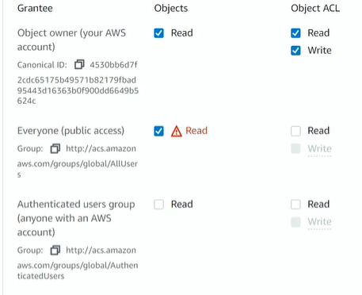

**Give read access to everyone public access 🡪 image appear**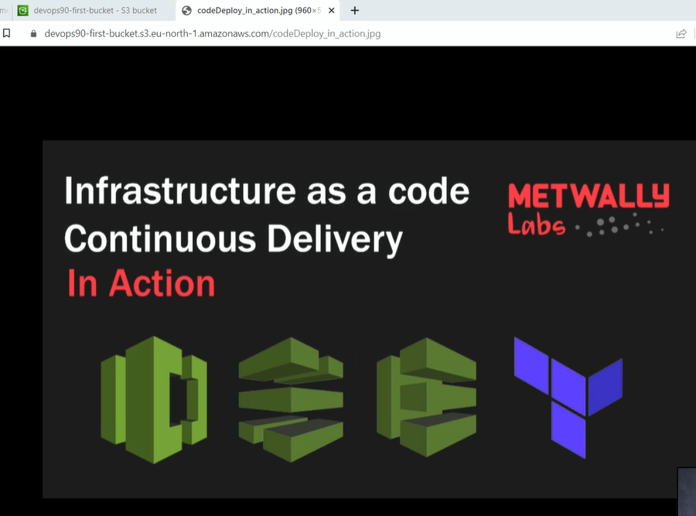

**S3 using CLI :**

1. **Open cli reference:**

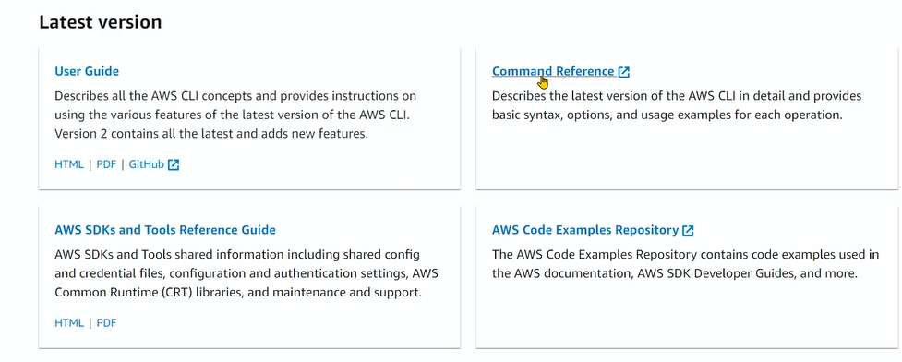

1. **Select S3**
2. 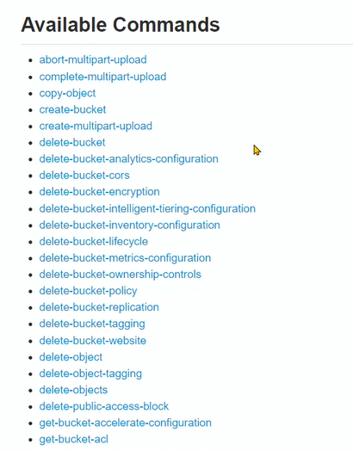
3. **Create bucket**
4. 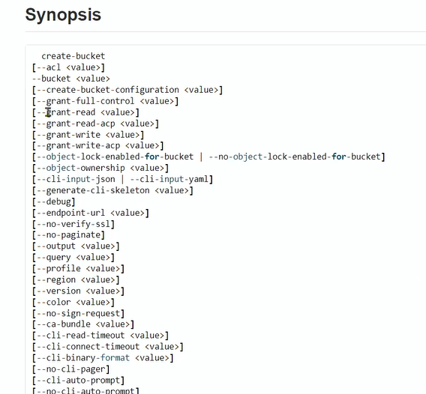

**Any argumrnt between [] are optional**



